6 DockerFile

1 dockerFile介绍
- dockerfile就是一个命令参数脚本，用来构建docker镜像！
- 镜像构建步骤：
- 便携一个dockerfile文件
- docker build 构建一个镜像
- docker run运行镜像 （docker build -f dockerfile1 -t gao/centos:1.0 .）
- docker push 发布镜像（dockerhub、阿里云镜像仓库）

centos官方dockerfile
FROM centos:7
ENV container docker
RUN (cd /lib/systemd/system/sysinit.target.wants/; for i in *; do [ $i == \
systemd-tmpfiles-setup.service ] || rm -f $i; done); \
rm -f /lib/systemd/system/multi-user.target.wants/*;\
rm -f /etc/systemd/system/*.wants/*;\
rm -f /lib/systemd/system/local-fs.target.wants/*; \
rm -f /lib/systemd/system/sockets.target.wants/*udev*; \
rm -f /lib/systemd/system/sockets.target.wants/*initctl*; \
rm -f /lib/systemd/system/basic.target.wants/*;\
rm -f /lib/systemd/system/anaconda.target.wants/*;
VOLUME [ "/sys/fs/cgroup" ]
CMD ["/usr/sbin/init"]
很多官方镜像都是基础包，很多功能没有，我们通常会搭建自己的镜像！
官方既然可以制作镜像，那我们也可以！

2 dockerFile构建过程

基础知识
- 每个关键字必须是大写字母
- 执行从上到下顺序执行
- #表示注释
- 每一行指令都是提交一个新的镜像层，并提交
dockerFile是面向开发的，我们发布项目做自己的镜像，就需要编写dockerfile文件！
docker镜像已逐渐成为企业交付的标准，必须掌握！
步骤：开发，部署，运维。
DockerFile：构建文件，定义了一个步骤，脚步代码。（自己写的）
DockerImages:通过DockerFile构建生成的镜像，最终发布和运行的产品，jar包
Docker容器：容器就是镜像运行起来提供服务的。

DockerFile指令
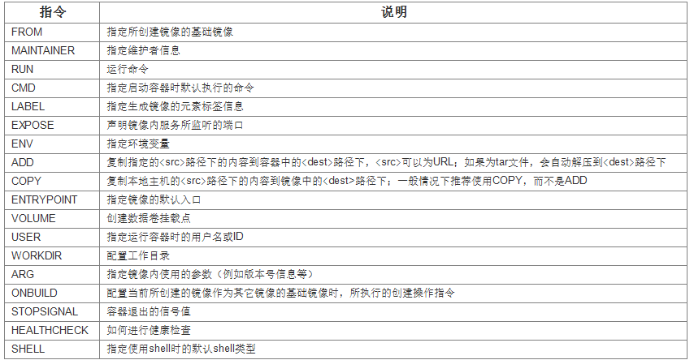
From #基础镜像，一切从这里开始构建 centos
MAINTAINER #镜像是谁写的，姓名+邮箱
RUN #镜像构建的时候需要运行的命令
ADD #添加内容，如搭建tomcat镜像，这里添加tocat压缩包！
WORKDIR #镜像的工作目录
VOLUME #挂载目录， -v
EXPOST #暴露端口，相当于-P
CMD #指定容器启动时要运行的命令，只有最后一个会生效，可被替代
ENTRYPOINT #指定容器启动时要运行的命令，可追加命令
ONBUID #当构建一个被继承的DockerFile时，就会触发ONBUILD指令。
COPY #类似于ADD命令，将本地文件拷贝到镜像中
ENV #构建时配置环境变量, 想到于-e
之前都是用别人的镜像，我们可以使用dockerFile来写自己的镜像！

实战测试
dockerhub中，大多镜像都是源于基础镜像 FROM scratch,然后配置需要的软件和配置进行构建。
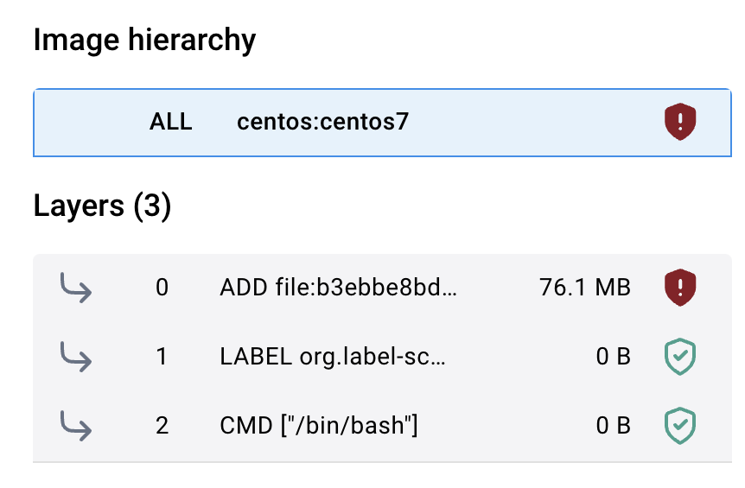
创建自己的docker镜像
我们在官方的centos上添加功能
#1、编写dockerFile文件
(base) ☁ dockerfile vim mydockerfile-centos
(base) ☁ dockerfile cat mydockerfile-centos
From centos
MAINTAINER gaochangliang<gaochl2014@126.com>

ENV MYPATH /usr/local
WORKDIR $MYPATH
#RUN echo "nameserver 8.8.8.8" > /etc/resolv.conf
ADD resolv.conf /etc/resolv.conf
#ADD Centos-8.repo /etc/yum.repos.d/CentOS-Base.repo
#RUN echo "nameserver 8.8.8.8" > /etc/resolv.conf
RUN cd /etc/yum.repos.d/
RUN sed -i 's/mirrorlist/#mirrorlist/g' /etc/yum.repos.d/CentOS-*
RUN sed -i 's|#baseurl=http://mirror.centos.org|baseurl=http://vault.centos.org|g' /etc/yum.repos.d/CentOS-*

RUN yum -y install vim
RUN yum -y install net-tools

EXPOSE 80

CMD echo $MYPATH
CMD echo "----end----"
CMD /bin/bash#2、通过dockerfile文件构建镜像
dockerfile docker build -f mydockerfile-centos -t mycentos:1.0 .
[+] Building 26.3s (13/13) FINISHED docker:desktop-linux
=> [internal] load build definition from mydockerfile-centos 0.0s
=> => transferring dockerfile: 686B 0.0s
=> [internal] load .dockerignore 0.0s
=> => transferring context: 2B 0.0s
=> [internal] load metadata for docker.io/library/centos:latest 0.0s
=> [1/8] FROM docker.io/library/centos 0.0s
=> [internal] load build context 0.0s
=> => transferring context: 69B 0.0s
=> CACHED [2/8] WORKDIR /usr/local 0.0s
=> CACHED [3/8] ADD resolv.conf /etc/resolv.conf 0.0s
=> [4/8] RUN cd /etc/yum.repos.d/ 0.1s
=> [5/8] RUN sed -i 's/mirrorlist/#mirrorlist/g' /etc/yum.repos.d/CentOS-* 0.2s
=> [6/8] RUN sed -i 's|#baseurl=http://mirror.centos.org|baseurl=http://vault.centos.org|g' /etc/yum.repos.d/CentOS- 0.3s
=> [7/8] RUN yum -y install vim 22.9s
=> [8/8] RUN yum -y install net-tools 2.7s
=> exporting to image 0.2s
=> => exporting layers 0.2s
=> => writing image sha256:358566aa7472b0b8f79ee060834b53f00a22d112e7a935e8426727a821a38a70 0.0s
=> => naming to docker.io/library/mycentos:1.0#测试运行

#测试是否成功
(base) ☁ dockerfile docker run -it --name "mycentos01" mycentos:1.0 /bin/bash
[root@2e73315e6369 local]# vim
[root@2e73315e6369 local]# ifconfig
eth0: flags=4163<UP,BROADCAST,RUNNING,MULTICAST> mtu 65535
inet 172.17.0.8 netmask 255.255.0.0 broadcast 172.17.255.255
ether 02:42:ac:11:00:08 txqueuelen 0 (Ethernet)
RX packets 8 bytes 656 (656.0 B)
RX errors 0 dropped 0 overruns 0 frame 0
TX packets 0 bytes 0 (0.0 B)
TX errors 0 dropped 0 overruns 0 carrier 0 collisions 0

lo: flags=73<UP,LOOPBACK,RUNNING> mtu 65536
inet 127.0.0.1 netmask 255.0.0.0
loop txqueuelen 1000 (Local Loopback)
RX packets 0 bytes 0 (0.0 B)
RX errors 0 dropped 0 overruns 0 frame 0
TX packets 0 bytes 0 (0.0 B)
TX errors 0 dropped 0 overruns 0 carrier 0 collisions 0
#命令成功安装
上过程yum install 问题：
1）、通过一下步骤未解决
https://blog.csdn.net/jiangjing0623/article/details/108245879
将centos镜像下到本地
Centos-7.repo
将centos镜像下载到本地，然后通过ADD添加到容器
2）、通过此方法解决
https://stackoverflow.com/questions/70963985/error-failed-to-download-metadata-for-repo-appstream-cannot-prepare-internal

可以通过docker history查看镜像构建的过程
#通过history查看构建过程
(base) ☁ dockerfile docker history mycentos:1.0
IMAGE CREATED CREATED BY SIZE COMMENT
358566aa7472 3 minutes ago CMD ["/bin/sh" "-c" "/bin/bash"] 0B buildkit.dockerfile.v0
<missing> 3 minutes ago CMD ["/bin/sh" "-c" "echo \"----end----\""] 0B buildkit.dockerfile.v0
<missing> 3 minutes ago CMD ["/bin/sh" "-c" "echo $MYPATH"] 0B buildkit.dockerfile.v0
<missing> 3 minutes ago EXPOSE map[80/tcp:{}] 0B buildkit.dockerfile.v0
<missing> 3 minutes ago RUN /bin/sh -c yum -y install net-tools # bu… 15.2MB buildkit.dockerfile.v0
<missing> 3 minutes ago RUN /bin/sh -c yum -y install vim # buildkit 62.2MB buildkit.dockerfile.v0
<missing> 3 minutes ago RUN /bin/sh -c sed -i 's|#baseurl=http://mir… 8.8kB buildkit.dockerfile.v0
<missing> 3 minutes ago RUN /bin/sh -c sed -i 's/mirrorlist/#mirrorl… 8.82kB buildkit.dockerfile.v0
<missing> 3 minutes ago RUN /bin/sh -c cd /etc/yum.repos.d/ # buildk… 0B buildkit.dockerfile.v0
<missing> 6 minutes ago ADD resolv.conf /etc/resolv.conf # buildkit 38B buildkit.dockerfile.v0
<missing> 19 minutes ago WORKDIR /usr/local 0B buildkit.dockerfile.v0
<missing> 19 minutes ago ENV MYPATH=/usr/local 0B buildkit.dockerfile.v0
<missing> 19 minutes ago MAINTAINER gaochangliang<gaochl2014@126.com> 0B buildkit.dockerfile.v0
<missing> 2 years ago /bin/sh -c #(nop) CMD ["/bin/bash"] 0B
<missing> 2 years ago /bin/sh -c #(nop) LABEL org.label-schema.sc… 0B
<missing> 2 years ago /bin/sh -c #(nop) ADD file:420712a90b0934202… 272MB
(base) ☁ docker history centos
IMAGE CREATED CREATED BY SIZE COMMENT
e6a0117ec169 2 years ago /bin/sh -c #(nop) CMD ["/bin/bash"] 0B
<missing> 2 years ago /bin/sh -c #(nop) LABEL org.label-schema.sc… 0B
<missing> 2 years ago /bin/sh -c #(nop) ADD file:420712a90b0934202… 272MB

CMD和ENTRRYPONIT区别
- CMD #指定容器启动时要运行的命令，只有最后一个会生效，可被替代
- ENTRYPOINT #指定容器启动时要运行的命令，可追加命令

- 先停止所有容器,让容器干净
#停止所有容器
docker stop $(docker ps -aq)
#删除所有容器
docker rm $(docker ps -aq)
- 测试CMD命令：
#创建dockerfile
(base) ☁ dockerfile cat dockerfile_cmd
FROM centos
CMD ["ls", "-a"]
#构建镜像
(base) ☁ dockerfile docker build -f dockerfile_cmd -t cmd_test .
[+] Building 0.0s (5/5) FINISHED
#run,发现ls -a是生效的
(base) ☁ dockerfile docker run -it cmd_test
. .dockerenv dev home lib64 media opt root sbin sys usr
.. bin etc lib lost+found mnt proc run srv tmp var

#在run的时候追加一个-l
(base) ☁ dockerfile docker run -it cmd_test -l
docker: Error response from daemon: failed to create task for container: failed to create shim task: OCI runtime create failed: runc create failed: unable to start container process: exec: "-l": executable file not found in $PATH: unknown.

#用cmd的情况下，run后的-l替换了CMD ["ls", "-a"]命令
#由于-l不是命令，所以报错
#使用正确的命令替换，就不会报错
(base) ☁ dockerfile docker run -it cmd_test ls -al
total 56
drwxr-xr-x 1 root root 4096 Jul 12 09:53 .
drwxr-xr-x 1 root root 4096 Jul 12 09:53 ..
......

测试ENTRYPOINT 命令
(base) ☁ dockerfile cat dockerfile-entrypoint
FROM centos
ENTRYPOINT ["ls", "-a"]
(base) ☁ dockerfile docker build -f dockerfile-entrypoint -t entryp-test .
[+] Building 0.0s (5/5) FINISHED
docker run entryp-test
(base) ☁ dockerfile docker run -it entryp-test
. .dockerenv dev home lib64 media opt root sbin sys usr
.. bin etc lib lost+found mnt proc run srv tmp var

#现在在run后面加-l
#-l直接追加载ENTRYPOINT ["ls", "-a"]后面
(base) ☁ dockerfile docker run -it entryp-test -l
total 56
drwxr-xr-x 1 root root 4096 Jul 12 09:58 .
drwxr-xr-x 1 root root 4096 Jul 12 09:58 ..
-rwxr-xr-x 1 root root 0 Jul 12 09:58 .dockerenv
......
Dockerfile中很多命令都非常相似，我们需要了解他们直接的区别

3 实战：Tomcat镜像
- 准备镜像文件,tomcat压缩包，jdk的压缩包
- 编写dockerfile文件,官方命名【Dockerfile】,build会自动寻找这个文件，就不需要-f指定文件
(base) ☁ tomcat vim dockerfile
FROM --platform=linux/amd64 centos #y
MAINTAINER gaochangliang<gaochl2014@126.com>

COPY readme.txt /usr/local/readme.txt

ADD apache-tomcat-9.0.91.tar.gz /usr/local/
ADD jdk-8u202-linux-x64.tar.gz /usr/local/

RUN cd /etc/yum.repos.d/
RUN sed -i 's/mirrorlist/#mirrorlist/g' /etc/yum.repos.d/CentOS-*
RUN sed -i 's|#baseurl=http://mirror.centos.org|baseurl=http://vault.centos.org|g' /etc/yum.repos.d/CentOS-*

RUN yum -y install vim

ENV MYPATH /usr/local
WORKDIR #MYPATH

ENV JAVA_HOME /usr/local/jdk1.8.0_202
ENV CLASSPATH $JAVA_HOME/lib/dt.jar:$JAVA_HOME/lib/tools.jar
ENV CATALINA_HOME /usr/local/apache-tomcat-9.0.91
ENV CATALINA_BASH /usr/local/apache-tomcat-9.0.91
ENV PATH $PATH:$JAVA_HOME/bin:$CATALINA_HOME/lib:$CATALINA_HOME/bin

EXPOSE 8080
CMD /usr/local/apache-tomcat-9.0.91/bin/startup.sh && tail -F /usr/local/apache-tomcat-9.0.91/logs/catline.out
- 创建镜像
(base) ☁ tomcat docker build -t mytomcat .
#docker build --platform linux/amd64 #如果dockerfile没有加上这句话，则需要在build的时候加上
- 创建容器
docker run -d -p 9090:8080 --name mytomcat01 -v /Users/gaochangliang/docker-learn/tomcat/test:/usr/local/apache-tomcat-9.0.91/webapps -v /Users/gaochangliang/docker-learn/tomcat/logs/:/usr/local/apache-tomcat-9.0.91/logs mytomcat
5 测试
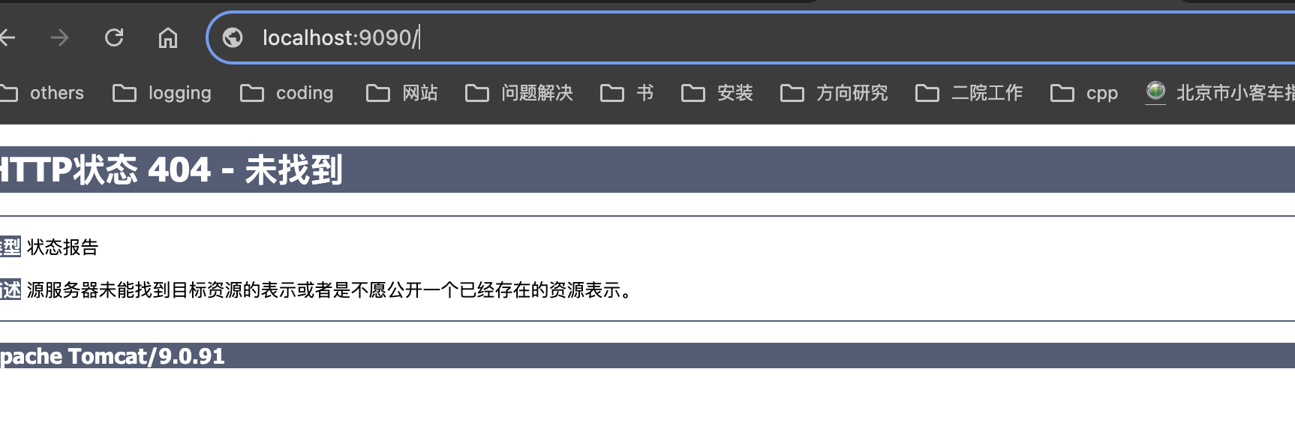
6 发布项目
由于使用容器数据卷技术实现本地挂载了，在本地书写项目可以，直接发布!

安装问题：
解决方案：docker build --platform linux/amd64 或者 FROM --platform linux/amd64
https://stackoverflow.com/questions/71040681/qemu-x86-64-could-not-open-lib64-ld-linux-x86-64-so-2-no-such-file-or-direc

4 发布自己的镜像

dockerhub
- 在dockerhub上注册自己的账号
- 确定这个账号可以登陆
- 在我们本地提交自己的镜像
#账号登陆
(base) ☁ docker-learn docker login --help
Log in to a Docker registry or cloud backend.
If no registry server is specified, the default is defined by the daemon.
Usage:
docker login [OPTIONS] [SERVER] [flags]
docker login [command]
Available Commands:
azure Log in to azure

Flags:
-h, --help Help for login
-p, --password string password
--password-stdin Take the password from stdin
-u, --username string username
- 登陆完毕后就可以提交镜像
#docker push 自己的镜像到镜像服务器
(base) ☁ docker-learn docker push mycentos:1.0
The push refers to repository [docker.io/library/mycentos]
0c5d06a20b39: Preparing
da3ada482d25: Preparing
fb562a09839f: Preparing
f14897ca93a8: Preparing
5f70bf18a086: Preparing
6e46e0e69637: Waiting
d871dadfb37b: Waiting
denied: requested access to the resource is denied

#如果这个问题
(base) ☁ docker-learn docker push gaochl/mycentos:1.0
The push refers to repository [docker.io/gaochl/mycentos]
An image does not exist locally with the tag: gaochl/mycentos
#说名本地不存在此标签，需要更改标签
(base) ☁ docker-learn docker tag 358566aa7472 gaochl/centos:1.0
#push 尽量带上版本号
(base) ☁ docker-learn docker push gaochl/centos:1.0
The push refers to repository [docker.io/gaochl/centos]
0c5d06a20b39: Preparing
da3ada482d25: Preparing
fb562a09839f: Preparing
f14897ca93a8: Preparing
5f70bf18a086: Preparing
6e46e0e69637: Waiting
d871dadfb37b: Waiting
denied: requested access to the resource is denied
#然后就push成功了
#提交的时候也是按照镜像的层次来提交的

阿里云镜像服务
- 登陆阿里云
- 容器镜像服务
- 创建一个命名空间（大项目）
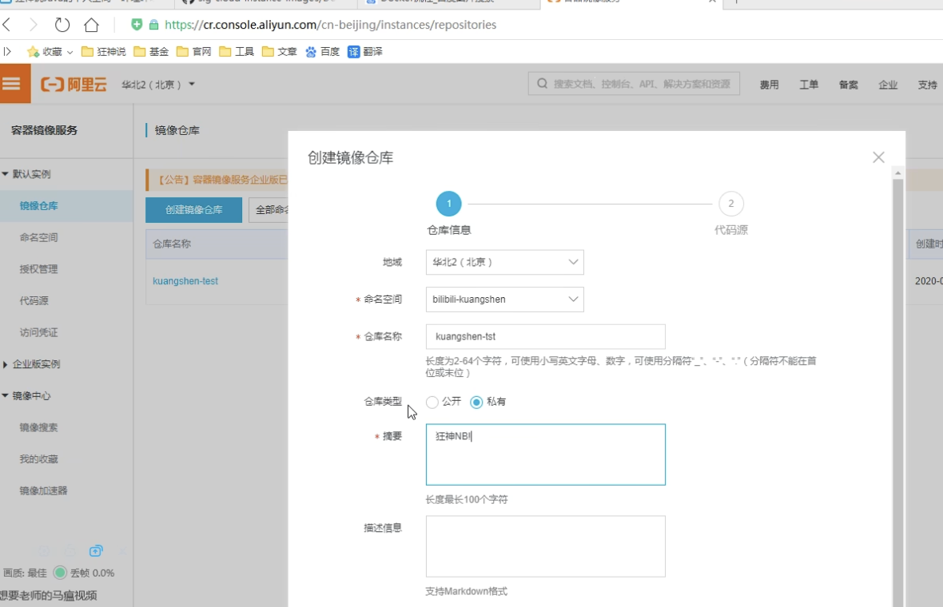

- 创建镜像
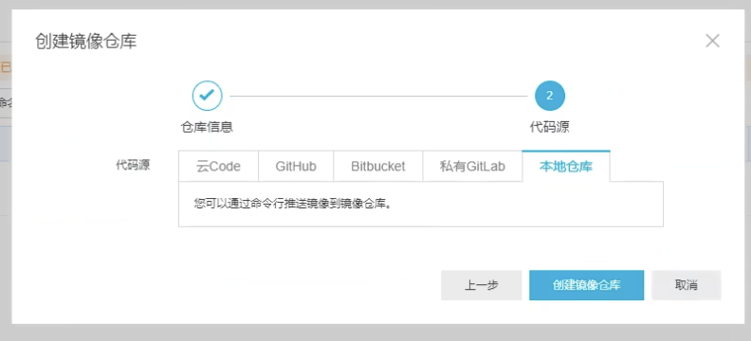
5、上传镜像
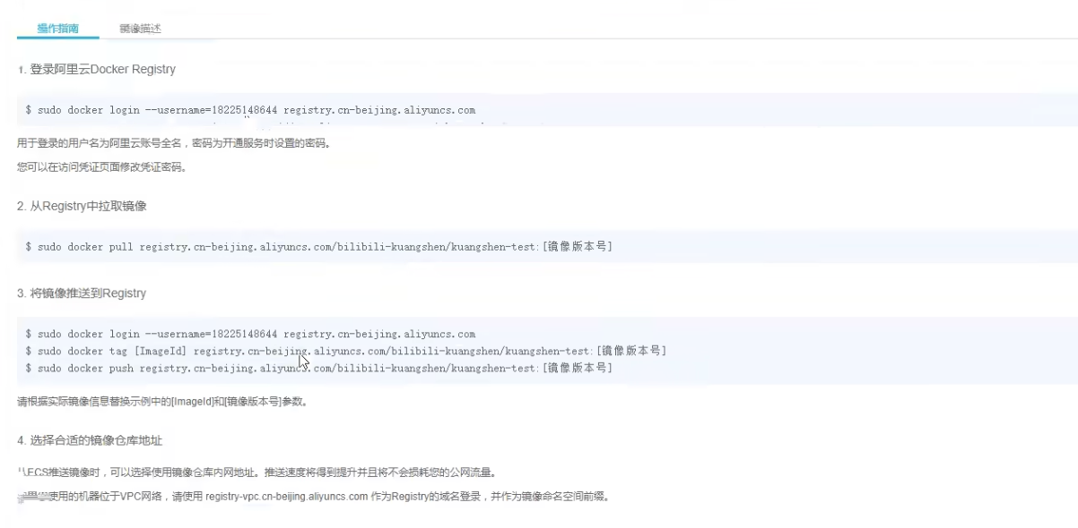

阿里云镜像的操作步骤，参考官方文档就好！·

小结
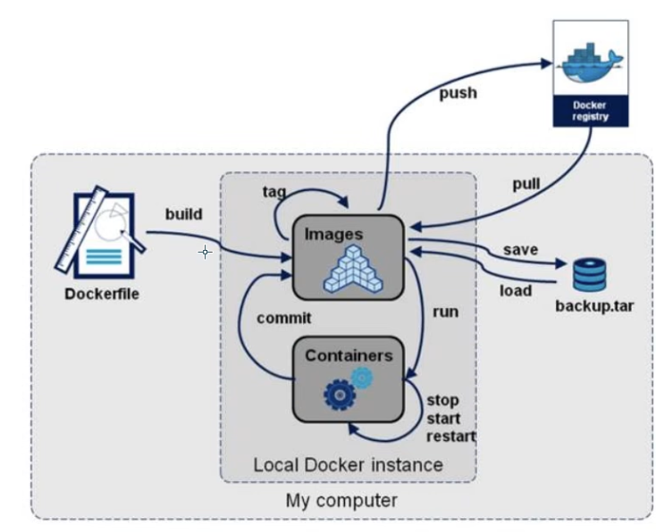
#Write to a file, instead of STDOUT
docker save -o 文件

#Read from tar archive file, instead of STDIN
docker load -i 文件

